7. The online beauty parlour appointment booking system allows users to browse available services, view stylist profiles, and check appointment slots in real-time. Users can register, log in, and manage their appointments through a personal dashboard. The booking process includes selecting services, choosing a stylist, selecting a date and time, and making secure payments via an integrated payment gateway (Stripe, PayPal or other methods, with full payment or a partial deposit). Admins can manage service offerings, stylist schedules, and user accounts through a comprehensive admin panel. Users receive appointment confirmation emails and reminders, with the option to reschedule or cancel appointments through their dashboard. Unavailable hours are locked out, unpaid reservations are cancelled automatically, and customers can leave feedback. The website is fully responsive for all devices.
AIM
To design a simple Beauty Parlour Appointment Booking webpage where users can book a service with a stylist, choose a date, time and payment method, and check or cancel their appointment.
HTML CODE
<!DOCTYPE html>
<html lang="en">
<head>
<meta charset="UTF-8">
<meta name="viewport" content="width=device-width, initial-scale=1">
<title>Beauty Parlour Appointment Booking</title>
<style>
body { font: 16px Arial, sans-serif; max-width: 650px; margin: 40px auto; padding: 20px; color: #222; background: #fff7fb; }
h1 { color: #c2185b; }
section { border: 1px solid #f1c6da; background: #fff; border-radius: 8px; padding: 20px; margin: 20px 0; }
input, select, button { padding: 10px; margin: 6px 0; width: 100%; box-sizing: border-box; }
button { background: #c2185b; color: #fff; border: 0; border-radius: 6px; cursor: pointer; }
.ok { color: #146c43; font-weight: bold; }
</style>
</head>
<body>
<h1>Glow Beauty Parlour</h1>
<section>
<h2>Book Appointment</h2>
<form id="bookForm">
<input id="name" placeholder="Customer name" required>
<select id="service">
<option>Haircut - Rs.600</option>
<option>Facial - Rs.1200</option>
<option>Bridal Makeup - Rs.8000</option>
</select>
<select id="stylist">
<option>Priya (Hair Expert)</option>
<option>Meena (Makeup Artist)</option>
<option>Anita (Skin Specialist)</option>
</select>
<input id="date" type="date" required>
<select id="time">
<option>10:00 AM</option>
<option>11:00 AM (Booked)</option>
<option>12:00 PM</option>
<option>02:00 PM</option>
</select>
<select id="payment">
<option>Full payment - Stripe</option>
<option>30% deposit - PayPal</option>
<option>Pay at salon</option>
</select>
<button type="submit">Confirm &amp; Pay</button>
</form>
<p id="bookResult"></p>
</section>
<section>
<h2>My Appointment</h2>
<input id="ref" placeholder="Enter booking ID" maxlength="6">
<button onclick="checkBooking()">Check Status</button>
<button onclick="cancelBooking()" style="background:#555">Cancel Appointment</button>
<p id="refResult"></p>
<small>Sample booking ID: GB1001</small>
</section>
<script>
let status = "Confirmed";
document.getElementById("bookForm").addEventListener("submit", function(event) {
event.preventDefault();
if (time.includes("Booked")) {
out.textContent = "Slot unavailable. Please choose another time.";
return;
}
out.className = "ok";
out.textContent = `Booking confirmed for ${document.getElementById("name").value}: ` +
`${document.getElementById("service").value}, ${document.getElementById("stylist").value}, ` +
`${document.getElementById("date").value} at ${time}. ID: GB1001. Email sent.`;
});
function checkBooking() {
const id = document.getElementById("ref").value;
? "Status: " + status + " - Facial with Priya, 02:00 PM (Payment: Paid)"
: "Booking not found.";
}
function cancelBooking() {
status = "Cancelled";
checkBooking();
}
</script>
</body>
</html>
OUTPUT
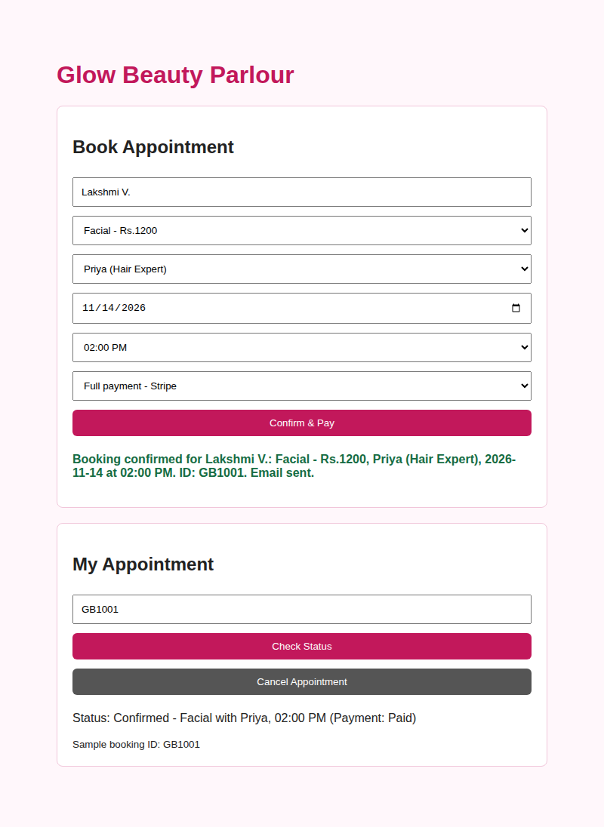  Output 1: Booking confirmed and status check | 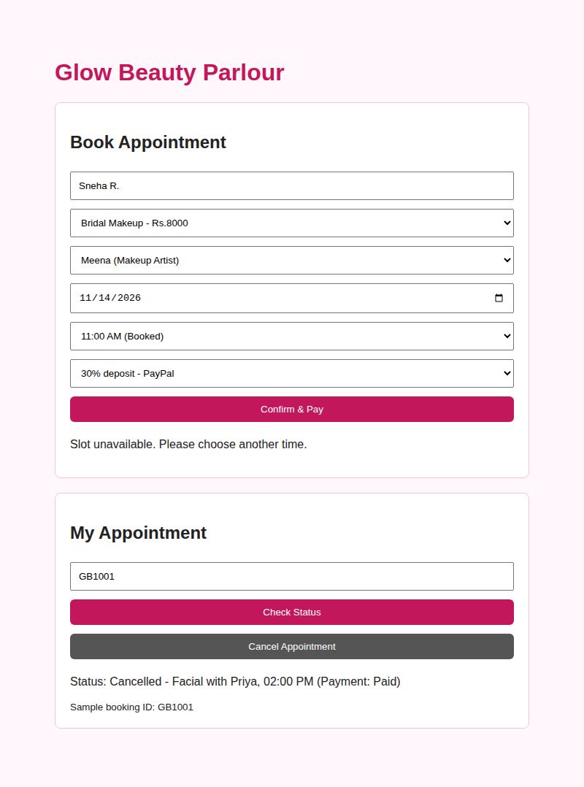  Output 2: Slot locked and appointment cancelled
RESULT
The Beauty Parlour Appointment Booking webpage was created successfully. It accepts the customer's service, stylist, date, time and payment choice, confirms the booking, blocks an unavailable slot, and shows or cancels the status of the sample booking ID GB1001.

